**Boğaziçi University**

**Software Engineering MS Program**

**SWE599 Project, Fall 2015**

**Supervisor: Fatih ALAGÖZ**

**Safe Send Project**

**Final Report**

**28.12.2015**

**Revision 1.0**

**By: Nuri Emre GÜRER**

**Student Id: 2013719174**

Table of Contents

1. Introduction 3

2. Overview 3

3. Work Done 4

3.1. Overall Structure and System Description 4

3.2. Performance Measurements 5

3.3. Interpretation of Results 5

4. Conclusions and Future Work 5

Appendix A: Requirements Specification Document 5

Appendix B: Design Specification Document 5

# 1. Introduction

The purpose of the project is to develop an iPhone application which transfers photos or videos to the contacts with a safe and secure way. The application provides safety and security with the encryption of the selected file.

Photos or videos of different content may need different security levels. A photo of a person with a city view may not require a high level of security on transferring it. On the other hand, a photo of a company’s annual financial report should require a high level of security. So the application offers to users different levels of encryption algorithms such as moderate, secure and highly secure.

# 2. Overview

The project consists of three main parts: ios application, wcf service and database. The database stores the user’s personal information and history of the file transfer operations. Wcf service provides the communication between the database and the ios application. Ios application’s function is to send and receive the photos and videos.

The user will select a contact from the contact list to send a photo or a video. After selecting the contact, thumbnails of the photos and videos will be displayed on the application. With the selection of the media, the user will select the level of encryption. According to the encryption level, the content of the media will be encrypted. Then, the encrypted data will be sent to the database via wcf service.

The receiver application will check if there exists a waiting file to receive. If there is, the receiver application will receive the data and the level of encryption via wcf service. The downloaded data will be decrypted according to the encryption level and the file will be saved to the storage.

# 3. Work Done

Mainly the project contains three development parts: database development, wcf service development and ios application development. Below table shows the works and their status on the project.

|  |  |  |
| --- | --- | --- |
| **No** | **Work** | **Status** |
| 1 | Requirements Specification Document | Completed |
| 2 | Design Specification Document | Completed |
| 3 | Database Design | Completed |
| 4 | WCF Service User Methods | Completed |
| 5 | WCF Service File Methods | Completed |
| 6 | WCF Service Deployment | Completed |
| 7 | ios Application Register and Login Screens | Completed |
| 8 | ios Application History Screen | Completed |
| 9 | ios Application Contact List Screen | Completed |
| 10 | ios Application File Transfer Operations | Completed |

# 3.1. Overall Structure and System Description

The Safe Send solution will comprise of following system components:

1. Mobile application
2. Web service application
3. Database

Mobile application constitutes the backbone of the project. User interacts with the mobile application. Web service application provides data for the mobile application.

Entity framework is used for the data access on the web service application.

The following diagram shows the data flow of the project.

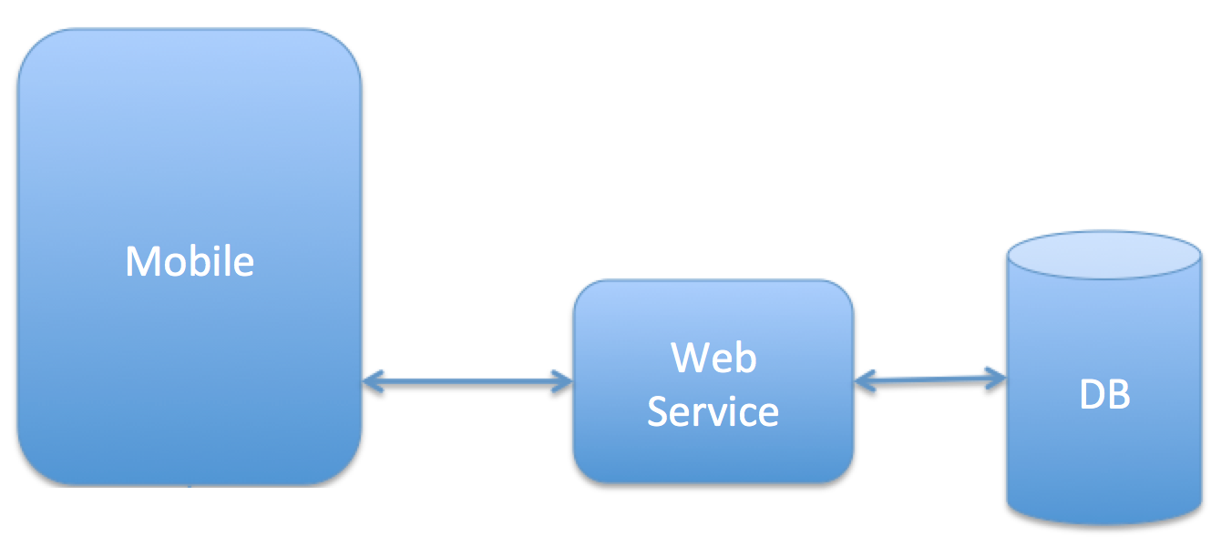

# 3.2. Performance Measurements

The following table shows the performance measurement values of the application.

|  |  |
| --- | --- |
| **File Size** | **Transfer Speed** |
| 252896 bytes | 2237 milliseconds |
| 252896 bytes | 1904 milliseconds |
| 1100816 bytes | 6360 milliseconds |
| 1100816 bytes | 7125 milliseconds |
| 1495952 bytes | 8541 milliseconds |
| 1495952 bytes | 8519 milliseconds |

Performance tests are run on an iPhone 6s mobile device.

# 3.3. Interpretation of Results

The values of the transfer speed increases when large size of files are transferred. Speed and size are directly proportional.

The values of the transfer speed is acceptable. Encryption of the file consumes most of the time. In future works, the content of the file may be compressed and then it can be encrypted. So, the transfer speed can be lowered.

# 4. Conclusions and Future Work

The application provided a safe and secure way for transferring data between mobile applications with the encryption of the content. A third party wcf service is used to transfer of the content.

In future work, peer to peer connection will be studied and there will be no need on the third party wcf service. Independency of the third party wcf service will increase the level of security. In addition to independency, compression of the content will be studied and therefore the speed of the transfer will be increased.

# Appendix A: Requirements Specification Document

# Appendix B: Design Specification Document